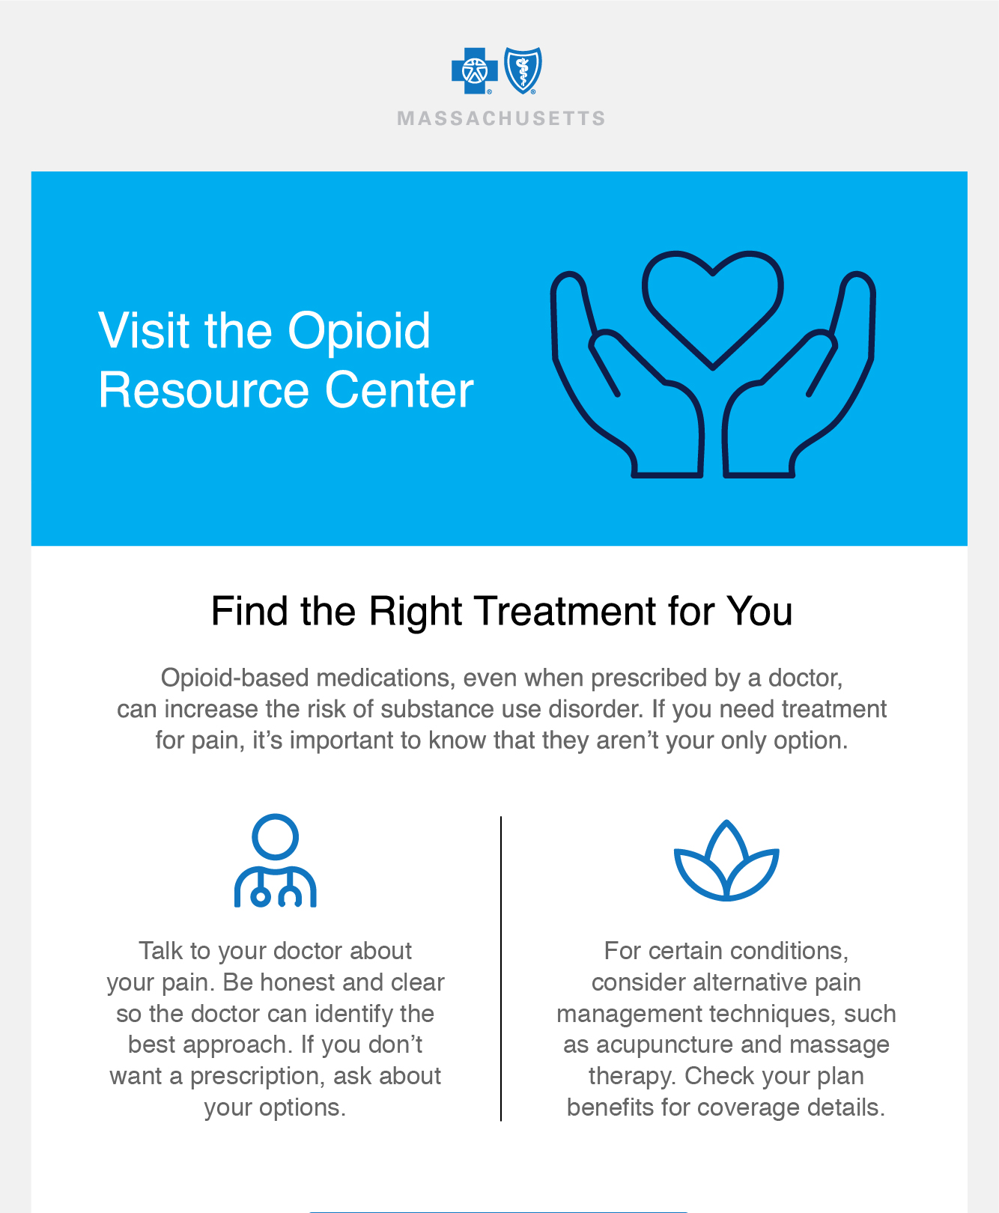

[](https://home.bluecrossma.com/opioid-treatment)

