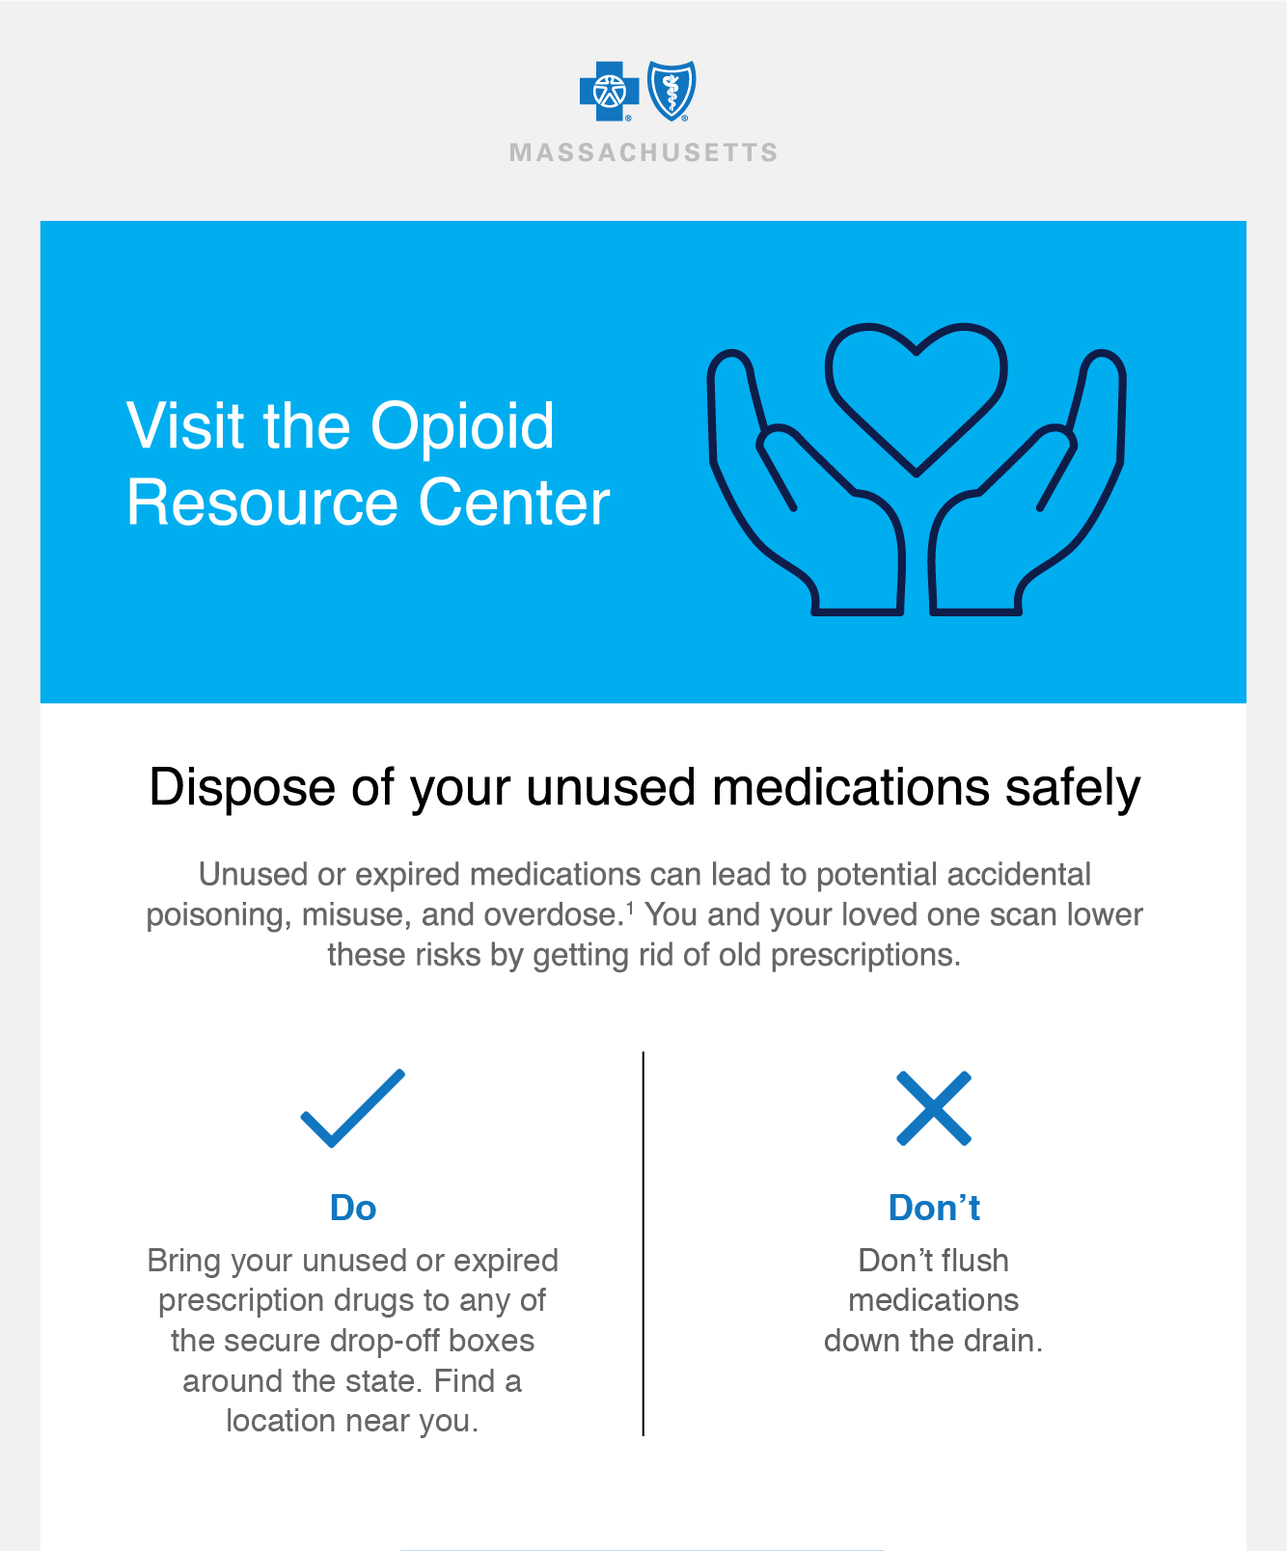

[](https://home.bluecrossma.com/opioid-prevention)

[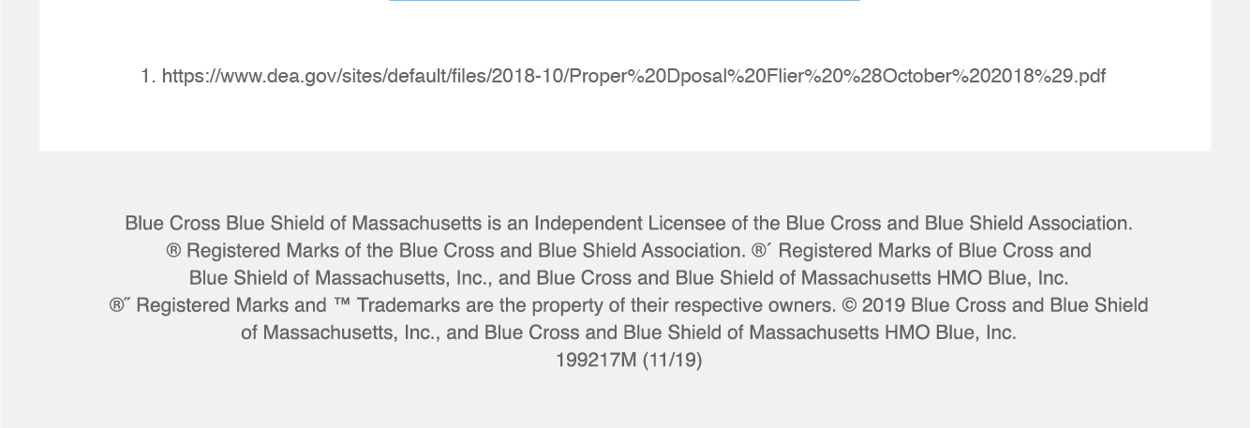](https://www.dea.gov/documents/2018/10/04/how-properly-dispose-your-unused-medicines)